# Flow Documentation - REquisiton status

|  |  |
| --- | --- |
| **Flow Name** | REquisiton status |
| **Flow ID** | fd40988a-8b36-49a3-85d5-29f74c5d8584 |
| **Documentation generated at** | 22 July 2023 10:07 |
| **Number of Variables** | 4 |
| **Number of Actions** | 15 |

## Flow Overview

The following chart shows the top level layout of the Flow. For a detailed view, please visit the section called Detailed Flow Diagram

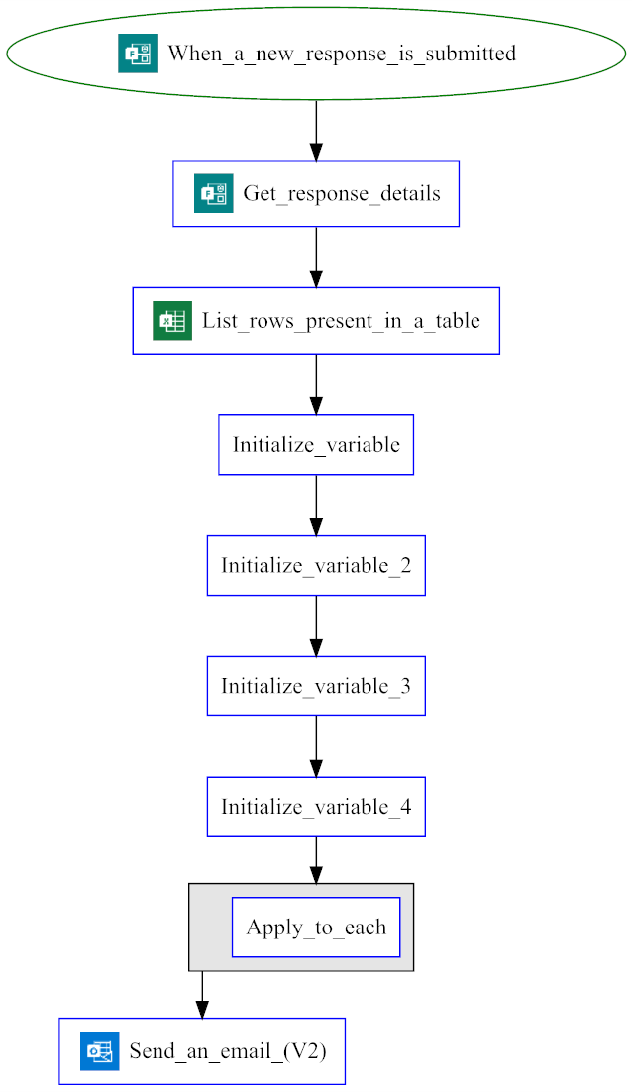

## Connections

There are a total of 3 connections used in this Flow:

### Excel Online (Business)

|  |  |  |  |
| --- | --- | --- | --- |
| **Connector** | |  |  | | --- | --- | |  | [Excel Online (Business)](https://docs.microsoft.com/connectors/excelonlinebusiness) | |
| **Connection Type** | Connector |
| **ID** | shared_excelonlinebusiness |
| **Source** | Embedded |

### Microsoft Forms

|  |  |  |  |
| --- | --- | --- | --- |
| **Connector** | |  |  | | --- | --- | |  | [Microsoft Forms](https://docs.microsoft.com/connectors/microsoftforms) | |
| **Connection Type** | Connector |
| **ID** | shared_microsoftforms |
| **Source** | Embedded |

### Office 365 Outlook

|  |  |  |  |
| --- | --- | --- | --- |
| **Connector** | |  |  | | --- | --- | |  | [Office 365 Outlook](https://docs.microsoft.com/connectors/office365) | |
| **Connection Type** | Connector |
| **ID** | shared_office365_1 |
| **Source** | Embedded |

## Variables

### Table

|  |  |
| --- | --- |
| **Name** | Table |
| **Type** | string |
| **Initial Value** | |  |  | | --- | --- | | **<tr> <td>S .No</td> <td>HasleftOrganization</td> <td>Roll</td> <td>SkillSet</td> <td>ClientName</td> <td>ProjectName</td> <td>ResourceType</td> <td>Hiring Status</td> <td>Date Of Requisition</td> <td>Deadline(date of req+30days)</td> </tr>** |  | |
| **Used in these Actions** | Initialize_variable |

### counter

|  |  |
| --- | --- |
| **Name** | counter |
| **Type** | integer |
| **Initial Value** | |  |  | | --- | --- | | **1** |  | |
| **Used in these Actions** | Increment_variable  Initialize_variable_2 |

### date of requisition

|  |  |
| --- | --- |
| **Name** | date of requisition |
| **Type** | string |
| **Initial Value** |  |
| **Used in these Actions** | Initialize_variable_3  Set_variable |

### deadline

|  |  |
| --- | --- |
| **Name** | deadline |
| **Type** | string |
| **Initial Value** |  |
| **Used in these Actions** | Initialize_variable_4  Set_variable_2 |

## Trigger

|  |  |
| --- | --- |
| **Name** | When_a_new_response_is_submitted |
| **Type** | OpenApiConnectionWebhook |
| **Connector** | microsoftforms |
| **Inputs Details** | |
| **host** | |  |  | | --- | --- | | apiId | /providers/Microsoft.PowerApps/apis/shared_microsoftforms | | connectionName | shared_microsoftforms | | operationId | CreateFormWebhook | |
| **parameters** | |  |  | | --- | --- | | form_id | epiJLMf1xkqTd4q-EaCLuBwp4QcTX-1HhCNGGhbZWNlUMDhLMUlSNVlFMFZYM0VBWkxRWEM1SU1OOS4u | |
| **authentication** | @parameters('$authentication') |
| **Other Trigger Properties** | |
| **splitOn** | @triggerOutputs()?['body/value'] |
| **metadata** | |  |  | | --- | --- | | operationMetadataId | a825ba09-41a1-4f3a-9193-835bc5f3f0ec | |

## Actions

There are a total of 15 actions used in this Flow:

### Append_to_string_variable_2

|  |  |
| --- | --- |
| **Name** | Append_to_string_variable_2 |
| **Type** | AppendToStringVariable |
| **Inputs** | |
| **metadata** | |  |  | | --- | --- | | operationMetadataId | cf9d3110-4e31-47fc-8604-94161398dad8 | |
| **name** | Table |
| **value** | <tr> <td>@{variables('counter')}</td> <td>@{items('Apply_to_each')?['HasLeftTheOrganization']}</td> <td>@{items('Apply_to_each')?['Role']}</td> <td>@{items('Apply_to_each')?['Skillset']}</td> <td>@{items('Apply_to_each')?['Clientname ']}</td> <td>@{items('Apply_to_each')?['Projectname']}</td> <td>@{items('Apply_to_each')?['Resourcetype']}</td> <td>@{items('Apply_to_each')?['Hiring Status']}</td> <td>@{variables('date of requisition')}</td> <td>@{variables('deadline')}</td> </tr> |
| **Next Action(s) Conditions** | Increment_variable [Succeeded] |

### Apply_to_each

|  |  |
| --- | --- |
| **Name** | Apply_to_each |
| **Type** | Foreach |
| **Inputs** | |
| **foreach** | @outputs('List_rows_present_in_a_table')?['body/value'] |
| **metadata** | |  |  | | --- | --- | | operationMetadataId | 91d68c69-7b9d-48e3-b86a-8e9b0aed62ce | |
| **Subactions** | Condition |
| **Next Action(s) Conditions** | Send_an_email_(V2) [Succeeded] |

### Condition

|  |  |
| --- | --- |
| **Name** | Condition |
| **Type** | If |
| **Expression** | |  |  |  |  |  |  | | --- | --- | --- | --- | --- | --- | | and | |  |  | | --- | --- | | equals | @items('Apply_to_each')?['HasLeftTheOrganization']  Open |  |  |  | | --- | --- | | equals | @items('Apply_to_each')?['Clientname ']  @outputs('Get_response_details')?['body/rfec0447f724847d8837333c822d4245c'] | | |
| **Inputs** | |
| **metadata** | |  |  | | --- | --- | | operationMetadataId | 4c45e2cd-835e-4309-a7b9-d0a3b9062d55 | |
| **Subactions** | Append_to_string_variable_2  Increment_variable  Scope  Scope_2 |

### Get_response_details

|  |  |
| --- | --- |
| **Name** | Get_response_details |
| **Type** | OpenApiConnection |
| **Connection** | |  |  | | --- | --- | |  | [Microsoft Forms](https://docs.microsoft.com/connectors/microsoftforms) | |
| **Inputs** | |
| **metadata** | |  |  | | --- | --- | | operationMetadataId | 85c31c45-2d08-4e42-9e34-4e2c250a57c8 | |
| **host** | |  |  | | --- | --- | | apiId | /providers/Microsoft.PowerApps/apis/shared_microsoftforms | | connectionName | shared_microsoftforms | | operationId | GetFormResponseById | |
| **parameters** | |  |  | | --- | --- | | form_id | epiJLMf1xkqTd4q-EaCLuBwp4QcTX-1HhCNGGhbZWNlUMDhLMUlSNVlFMFZYM0VBWkxRWEM1SU1OOS4u | | response_id | @triggerOutputs()?['body/resourceData/responseId'] | |
| **authentication** | @parameters('$authentication') |
| **Next Action(s) Conditions** | List_rows_present_in_a_table [Succeeded] |

### Increment_variable

|  |  |
| --- | --- |
| **Name** | Increment_variable |
| **Type** | IncrementVariable |
| **Inputs** | |
| **metadata** | |  |  | | --- | --- | | operationMetadataId | b9a8983b-e128-4e2b-816e-837f8f55a02f | |
| **name** | counter |
| **value** | 1 |

### Initialize_variable

|  |  |
| --- | --- |
| **Name** | Initialize_variable |
| **Type** | InitializeVariable |
| **Inputs** | |
| **metadata** | |  |  | | --- | --- | | operationMetadataId | fa028424-7e83-4e16-8916-b694034712ca | |
| **variables** | |  |  | | --- | --- | | name | Table | | type | string | | value | <tr> <td>S .No</td> <td>HasleftOrganization</td> <td>Roll</td> <td>SkillSet</td> <td>ClientName</td> <td>ProjectName</td> <td>ResourceType</td> <td>Hiring Status</td> <td>Date Of Requisition</td> <td>Deadline(date of req+30days)</td> </tr> | |
| **Next Action(s) Conditions** | Initialize_variable_2 [Succeeded] |

### Initialize_variable_2

|  |  |
| --- | --- |
| **Name** | Initialize_variable_2 |
| **Type** | InitializeVariable |
| **Inputs** | |
| **metadata** | |  |  | | --- | --- | | operationMetadataId | 462e75dd-f806-4820-8f15-e60a4a27610e | |
| **variables** | |  |  | | --- | --- | | name | counter | | type | integer | | value | 1 | |
| **Next Action(s) Conditions** | Initialize_variable_3 [Succeeded] |

### Initialize_variable_3

|  |  |
| --- | --- |
| **Name** | Initialize_variable_3 |
| **Type** | InitializeVariable |
| **Inputs** | |
| **metadata** | |  |  | | --- | --- | | operationMetadataId | 027d14ff-7012-4d3a-8acc-217a6f937605 | |
| **variables** | |  |  | | --- | --- | | name | date of requisition | | type | string | |
| **Next Action(s) Conditions** | Initialize_variable_4 [Succeeded] |

### Initialize_variable_4

|  |  |
| --- | --- |
| **Name** | Initialize_variable_4 |
| **Type** | InitializeVariable |
| **Inputs** | |
| **metadata** | |  |  | | --- | --- | | operationMetadataId | 55934f1a-5d29-43a0-95bc-67569b37ef69 | |
| **variables** | |  |  | | --- | --- | | name | deadline | | type | string | |
| **Next Action(s) Conditions** | Apply_to_each [Succeeded] |

### List_rows_present_in_a_table

|  |  |
| --- | --- |
| **Name** | List_rows_present_in_a_table |
| **Type** | OpenApiConnection |
| **Connection** | |  |  | | --- | --- | |  | [Excel Online (Business)](https://docs.microsoft.com/connectors/excelonlinebusiness) | |
| **Inputs** | |
| **metadata** | |  |  | | --- | --- | | 01XFZUCKSXAQPB7KNLDZGKBRUGFU74QY5F | /Recruitment/Resources Needed/Requisition1.xlsx | | operationMetadataId | ab5efc50-4a3c-4e2c-83dc-ddce187f9ec9 | | tableId | {00000000-000C-0000-FFFF-FFFF00000000} | |
| **host** | |  |  | | --- | --- | | apiId | /providers/Microsoft.PowerApps/apis/shared_excelonlinebusiness | | connectionName | shared_excelonlinebusiness | | operationId | GetItems | |
| **parameters** | |  |  | | --- | --- | | source | groups/a4e930cc-25dc-4635-901a-264413185b94 | | drive | b!6zCLhzwwXkmRg1Vv6qgzIqniyIUYUnlAsRW910HzA436Z6o5335USbByNPN0PU5a | | file | 01XFZUCKSXAQPB7KNLDZGKBRUGFU74QY5F | | table | {00000000-000C-0000-FFFF-FFFF00000000} | |
| **authentication** | @parameters('$authentication') |
| **runtimeConfiguration** | |  |  |  |  | | --- | --- | --- | --- | | paginationPolicy | |  |  | | --- | --- | | minimumItemCount | 5000 | | |
| **Next Action(s) Conditions** | Initialize_variable [Succeeded] |

### Scope

|  |  |
| --- | --- |
| **Name** | Scope |
| **Type** | Scope |
| **Inputs** | |
| **metadata** | |  |  | | --- | --- | | operationMetadataId | 0fbb14d6-b77b-47ec-a5de-8e2c01f29af6 | |
| **Subactions** | Set_variable  Set_variable_2 |
| **Next Action(s) Conditions** | Append_to_string_variable_2 [Succeeded]  Scope_2 [Failed] |

### Scope_2

|  |  |
| --- | --- |
| **Name** | Scope_2 |
| **Type** | Scope |
| **Inputs** | |
| **metadata** | |  |  | | --- | --- | | operationMetadataId | 3cc098d8-17d1-4f54-8da6-f80bb7528c1d | |

### Send_an_email_(V2)

|  |  |
| --- | --- |
| **Name** | Send_an_email_(V2) |
| **Type** | OpenApiConnection |
| **Connection** | |  |  | | --- | --- | |  | [Office 365 Outlook](https://docs.microsoft.com/connectors/office365) | |
| **Inputs** | |
| **metadata** | |  |  | | --- | --- | | operationMetadataId | 76a71d86-2b9a-470c-ae63-5b98441b116f | |
| **host** | |  |  | | --- | --- | | apiId | /providers/Microsoft.PowerApps/apis/shared_office365 | | connectionName | shared_office365_1 | | operationId | SendEmailV2 | |
| **parameters** | |  |  | | --- | --- | | emailMessage/To | @{outputs('Get_response_details')?['body/responder']};prakhar@monocept.com;aditya@monocept.com | | emailMessage/Subject | Hiring status | | emailMessage/Body | <style> table, td { border:2px solid black; border-collapse:collapse; text-align:center; background-color: rgba(0,0,0,0.1); } th { border:2px solid black; border-collapse:collapse; text-align:center; background-color:#002b80; color:white; } </style> <h3>Hiring Status</h3> <table style="border:1px solid black"> @{variables('Table')} </table> | | emailMessage/Importance | Normal | |
| **authentication** | @parameters('$authentication') |

### Set_variable

|  |  |
| --- | --- |
| **Name** | Set_variable |
| **Type** | SetVariable |
| **Inputs** | |
| **metadata** | |  |  | | --- | --- | | operationMetadataId | b198f449-d44d-4302-96bc-e8243d8a0d46 | |
| **name** | date of requisition |
| **value** | @{addDays('1899-12-30', int(items('Apply_to_each')?[concat('Date of new requisition', '/', 'replacement')]), 'dd-MM-yyyy')} |
| **Next Action(s) Conditions** | Set_variable_2 [Succeeded] |

### Set_variable_2

|  |  |
| --- | --- |
| **Name** | Set_variable_2 |
| **Type** | SetVariable |
| **Inputs** | |
| **metadata** | |  |  | | --- | --- | | operationMetadataId | e2f40910-a9ff-4828-8609-e21de6670e6f | |
| **name** | deadline |
| **value** | @{addDays('1900-01-29', int(items('Apply_to_each')?[concat('Date of new requisition', '/', 'replacement')]), 'dd-MM-yyyy')} |

## Detailed Flow Diagram

The following chart shows the detailed layout of the Flow

